**“College Network”**

A COURSE PROJECT REPORT

By

**E.V.Hemanth Nag(RA1911026010016)**

**Gayar Sai Kamal (RA1911026010017)**

**Saket Aggarwal (RA1911026010059)**

Under the guidance of

**Subject Handling Faculty Name**

*In partial fulfilment for the Course*

Of

18csc302J – COMPUTER NETWORKS

In

Department Name



# FACULTY OF ENGINEERING AND TECHNOLOGY SRM INSTITUTE OF SCIENCE AND TECHNOLOGY

## Kattankulathur, Chenpalpattu District

## NOVEMBER 2021

**SRM INSTITUTE OF SCIENCE AND TECHNOLOGY**

**(Under Section 3 of UGC Act, 1956)**

**BONAFIDE CERTIFICATE**

**Certified that this project report "Compuet Network " is the bonafide work of E.V.Hemanth Nag(RA1911026010016), Gayar Sai Kamal(RA1911026010017),**

**Saket Aggarwal(RA1911026010059) who carried out the project work under my supervision.**

**SIGNATURE**

**SIGNATURE**

**Subject Staff**

Designation

Department

**Dr.P. SARVANAN,**

Course Cordinator

Associate Professor,

SRM Institute of Science and Technology Potheri, SRM Nagar, Kattankulathur, Tamil Nadu 603203

Data Science and Business Systems SRM Institute of Science and Technology Potheri, SRM Nagar, Kattankulathur, Tamil Nadu 60320

# ACKNOWLEDGEMENT

We express our heartfelt thanks to our honorable **Vice Chancellor Dr. C. MUTHAMIZHCHELVAN**, for being the beacon in all our endeavors.

We would like to express my warmth of gratitude to our **Registrar Dr. S. Ponnusamy,** for his encouragement

We express our profound gratitude to our **Dean (College of Engineering and Technology) Dr. T. V.Gopal,** for bringing out novelty in all executions.

We would like to express my heartfelt thanks to Chairperson, School of Computing **Dr. Revathi Venkataraman,** for imparting confidence to complete my course project

We wish to express my sincere thanks to **Course Audit Professor Dr.M.LAKSHMI, Professor and Head, Data Science and Business Systems** and **Course Cordinator Dr.E. Sasikala, Associate Professor, Data Science and Business Systems** for their constant encouragement and support.

We are highly thankful to our my Course project Internal guide **Subject handling staff name , Designation , Department,** for **his/her** assistance, timely suggestion and guidance throughout the duration of this course project.

We extend my gratitude to **Student HOD name Department** and my Departmental colleagues for their Support.

Finally, we thank our parents and friends near and dear ones who directly and indirectly contributed to the successful completion of our project. Above all, I thank the almighty for showering his blessings on me to complete my Course project

# TABLE OF CONTENTS

**CHAPTER CONTENTS PAGE NO.**

* + - 1. **ABSTRACT and Introduction**
      2. **Objectives**
      3. **REQUIREMENT ANALYSIS**
      4. **Major Design Areas and Functional Areas**
      5. **Existing Infrastructure**
      6. **Implementation**

Network Devices

Request for Proposal (RFP)

IP addressing Plan

Routing Protocol Plan

* + - 1. **EXPERIMENT RESULTS & ANALYSIS**

NETWORK DESIGN

RESULTS

CONCLUSION & FUTURE WORK

* + - 1. **REFERENCES**

**Abstract and Introduction**

This College Network Scenario is about designing a topology of a network that is a LAN (Local Area Network) for a College in which various computers of different departments are set up so that they can interact and communicate with each other by interchanging data. To design a networking scenario for a college which connect various departments to each other’s, it puts forward communication among different departments. CNS is used to design a systematic and well-planned topology, satisfying all the necessities of the college (i.e. client). CNS come up with a network with good performance.

# Objectives

The main objective of the proposed network is to update the existing network and also enhance its capabilities and increase the flexibility of the network which will eventually provide good security.

# Requirement Analysis

1: The new system should be able to reduce internet downtime. Download and upload links should be maintained above 5 Mbps speed requirement.

2: Network will be scalable.

3: The system should support remote access.

4: Should comprise of data centers with necessary security features and support.

# Major Design Areas and Functional Areas

The new system planned comprises of IP based switches that remain as the access point to lan-based (ethernet) as well as Wi-Fi-based connectivity.

These switches provide SNMP support as well so that traffic monitoring becomes easy. Ip based switches are used mainly because:

* The inter VLAN routing feature is supported on both IP base or SMI and IP services or EMI image Layer 3 switches. For Layer 2-only switches, you require a Layer 3 routing device with any of the previous images.

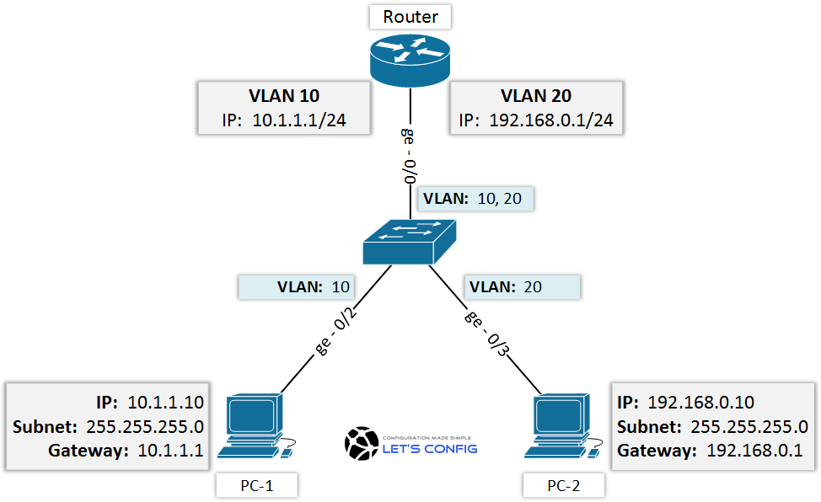-

*VLAN Config*

* The IP Base feature set includes advanced quality of service (QoS), rate limiting, access control lists (ACLs), and basic static and Routing Information Protocol (RIP) functions. Dynamic IP routing protocols (Open Shortest Path First (OSPF), BGPv4, Enhanced Interior Gateway Routing Protocol (EIGRP)) are available only on the IP services image.
* The IP Services image provides a richer set of enterprise-class features, which includes advanced hardware-based IP unicast and IP Multicast routing. Support for IPv6 Layer 3 switching in hardware is also available with the addition of the Advanced IP Services license to either the IP Base or the IP Services images. Both the IP base Image and the IP services image allow for Layer 3 and Layer 4 lookups for QoS and security.

# Existing Infrastructure

The existing system is a very basic system. College mainly comprises of three main sections as

1. TPO & Other
2. Exam Center
3. Office

All the hosts are assigned with static IPs and are assigned in the order in which it where set up. No support for dynamic IP allocations. Even though the working is divided into three major sectors all the host, multimedia devices are connected in a single network. Thus, network security and maintenance are difficult. One more problem observed was the existing switches were outdated and hence could not prove to be beneficial for the network administrator to observe monitor and handle the network traffic the system has no remote access to the network. Absence of basic small-scale businesses firewall was also observed. Thus, security is also compromised. Three server rooms were used for the purpose of independent networking which further caused wastage of power and money.

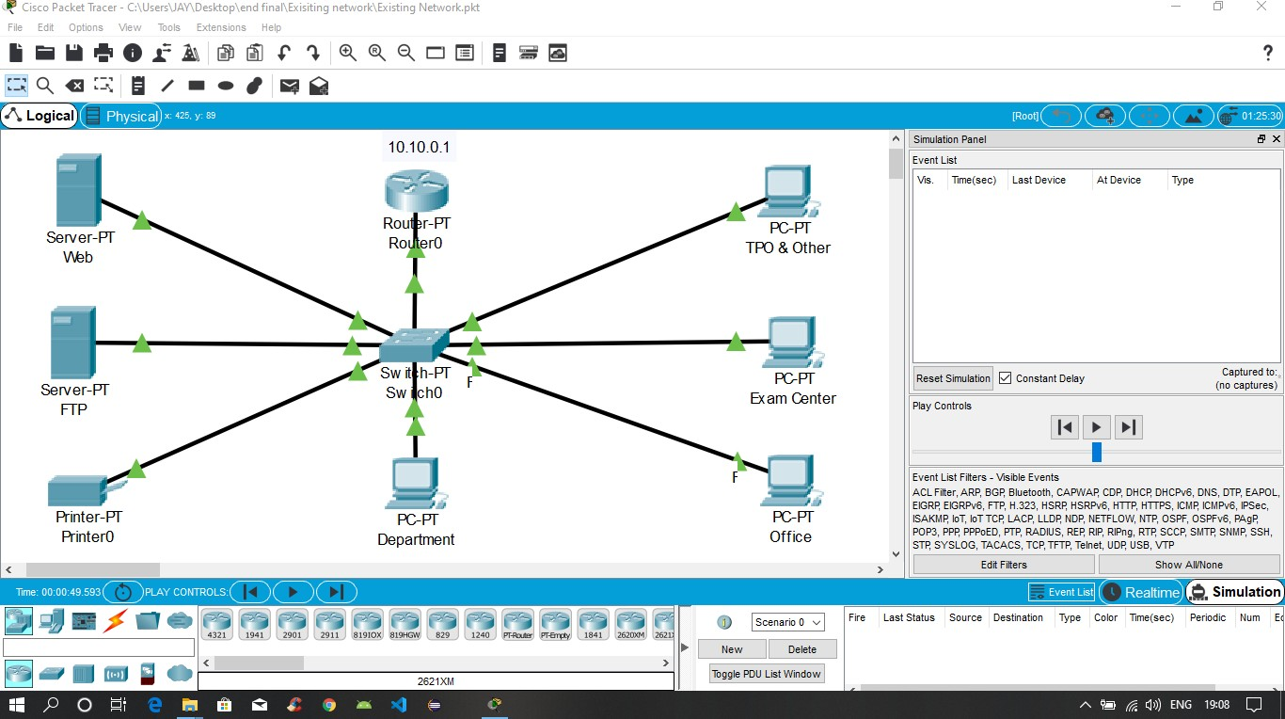

*The above design is the existing network traced on cisco packet tracer.*

**Implementation**

# Network Devices

Developing the existing Lan system:

* + The basis of the LAN core is Cisco Catalyst 6509 switches equipped with Cisco 720 supervisors and Virtual Switching System (VSS), as well as Cisco 4500 switches, combined in a stack with the data transmission ports at 10 Gb/s bandwidth capacity. Switches create a platform for additional services, such as content processing, firewall (the project uses the Cisco firewall), intrusion prevention system, application of IPsec security tools, the arrangement of protected VPN channels, network analysis and acceleration of Secure Sockets Layer (SSL) connections.

Mobility Services Engine (MSE) solution and 300 Cisco Aironet 1140 access points were used.

* + The Cisco Aironet 1140 Series is a component of the Cisco Unified Wireless Network, which can scale up to 18,000 [access points](https://www.cisco.com/en/US/products/ps5678/Products_Sub_Category_Home.html) with full Layer 3 mobility across central or remote locations on the enterprise campus, in branch offices, and at remote sites.
  + The Cisco Unified Wireless Network is the industry’s most flexible, resilient, and scalable architecture, delivering secure access to mobility services and applications and offering the lowest total cost of ownership and investment protection by integrating seamlessly with the existing wired network.

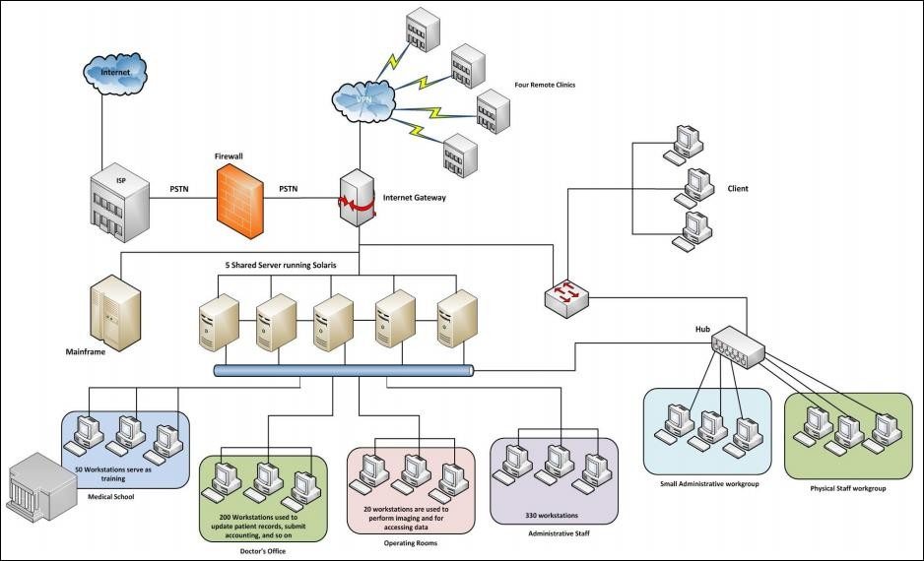

*Above is the pictorial representation of the proposed network*

Cisco Unified Computing System (UCS) solution allowed the integration of computer and network resources as well as storage and virtualization systems as part of an energy efficiency system. Cisco Unified Computing System platform notably simplifies traditional architecture and significantly reduces the number of devices to be purchased, to connect by wires, to supply with electricity and cooling, to protect and maintain. This solution is the foundation of complex optimization of the virtualized medium while maintaining the ability to support traditional operating systems and applications stacks in physical medium. This overall infrastructure developed allowed integration of several functionally different physical networks into one, such as guest network, hotel management network, telephone network and IP-Television network. The convergence within single network reduced hotel expenses for constructing and managing several dedicated networks which traditionally remain separate in hotels.

The term unified computing system is often associated with Cisco. Cisco UCS products have the ability to support traditional operating system ([OS](https://whatis.techtarget.com/definition/operating-system-OS)) and application stacks in physical environments, but are optimized for [virtualized](https://searchservervirtualization.techtarget.com/definition/virtualization) environments. Everything is managed through Cisco UCS Manager, a software application that allows administrators to provision the server, storage and network resources all at once from a [single pane of glass](https://searchconvergedinfrastructure.techtarget.com/definition/single-pane-of-glass). Similar offerings to Cisco UCS include HP BladeSystem Matrix, Liquid Computing's LiquidIQ, Sun Modular Datacenter and InteliCloud 360.

**Request For Proposal**

|  |  |  |  |  |
| --- | --- | --- | --- | --- |
| **Serial no** | **Network Devices** | **Price per unit**  (Approx.) | **Quantity** | **Total cost (INR)** |
| 1 | The Cisco System Business switches | 17,999 | 6 | 108,000 |
| 2 | Cisco RV042G: | 8000 | 3 | 24,000 |
| 3 | Wires | 25000 | 2 | 50000 |
|  | | | **Total** | **182,000** |

**IP Addressing Plan**

|  |  |
| --- | --- |
| **IT DEPARTMENT (192.168.1.0)** | |
| HOD CABIN | 192.168.1.2 |
| IT LAB 1 | 192.168.1.3 |
| IT LAB 2 | 192.168.1.4 |
| IT LAB 3 | 192.168.1.5 |
| IT LAB 4 | 192.168.1.6 |
| Printer 0 | 192.168.1.7 |

|  |  |
| --- | --- |
| **COMPUTER DEPARTMENT (192.168.2.0)** | |
| CS HOD CABIN | 192.168.2.2 |
| CS LAB 1 | 192.168.2.3 |
| CS LAB 2 | 192.168.2.4 |
| CS LAB 3 | 192.168.2.5 |
| CS LAB 4 | 192.168.2.6 |
| Printer 7 | 192.168.2.7 |

|  |  |
| --- | --- |
| **OTHERS (192.168.3.0)** | |
| OFFICE | 192.168.3.2 |
| Printer 2 | 192.168.3.6 |
| EXAM CELL | 192.168.3.3 |
| Printer 3 | 192.168.3.7 |
| ENQUIRY | 192.168.3.4 |
| TPO | 192.168.3.5 |
| Printer 4 | 192.168.3.8 |

|  |  |
| --- | --- |
| **SERVER ROOM (1.0.0.0)** | |
| FTP SERVER | 1.0.0.4 |
| PC1 | 1.0.0.5 |
| DNS SERVER | 1.0.0.2 |
| WEB SERVER | 1.0.0.3 |

|  |  |
| --- | --- |
| **INTERNET LAB (128.168.0.0)** | |
| PC2 | 128.168.0.2 |
| PC3 | 128.168.0.3 |
| PC4 | 128.168.0.4 |
| PC5 | 128.168.0.5 |
| Printer 5 | 128.168.0.6 |

|  |  |
| --- | --- |
| **PRINCIPLE ROOM (192.168.4.0)** | |
| PC 0 | 192.168.4.2 |
| LAPTOP 0 | 192.168.4.3 |

# Routing Protocol Plan

Routing Information Protocol (RIP) is a dynamic routing protocol which uses hop count as

a routing metric to find the best path between the source and the destination network. It is a distance vector routing protocol which has AD value 120 and works on the application layer of OSI model.

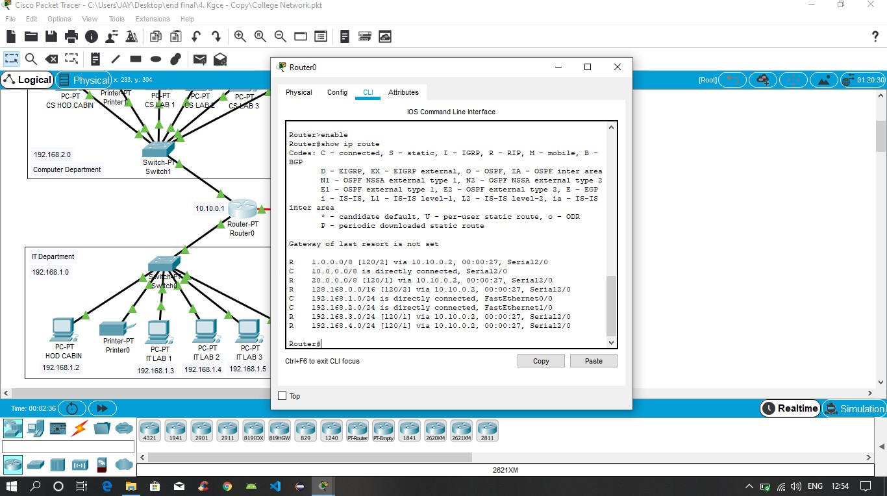

*Routing Protocol Plan for Router0*

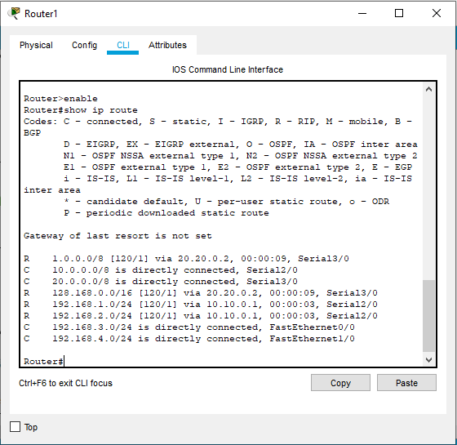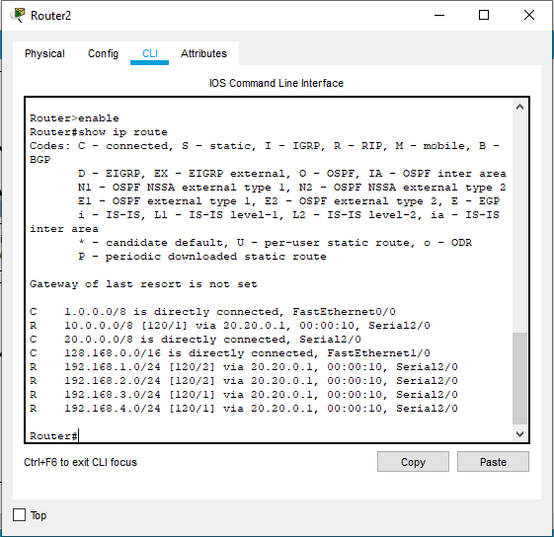

*Routing Protocol Plan for Router1 Routing Protocol Plan for Router2*

**EXPERIMENT RESULTS & ANALYSIS**

# Network Design

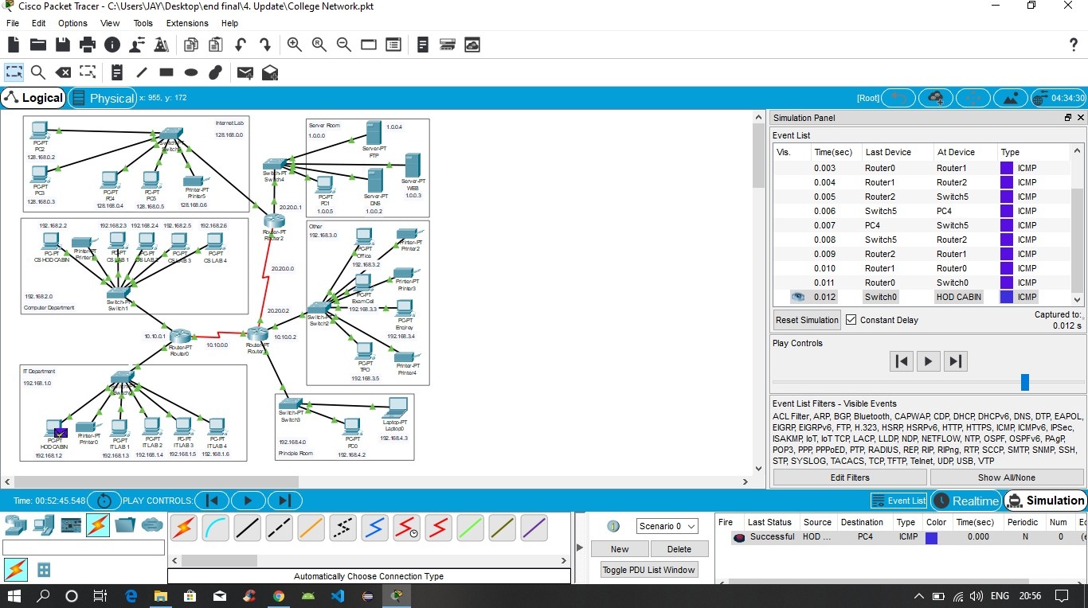

*The prototype of the proposed network is implemented on cisco packet tracer*

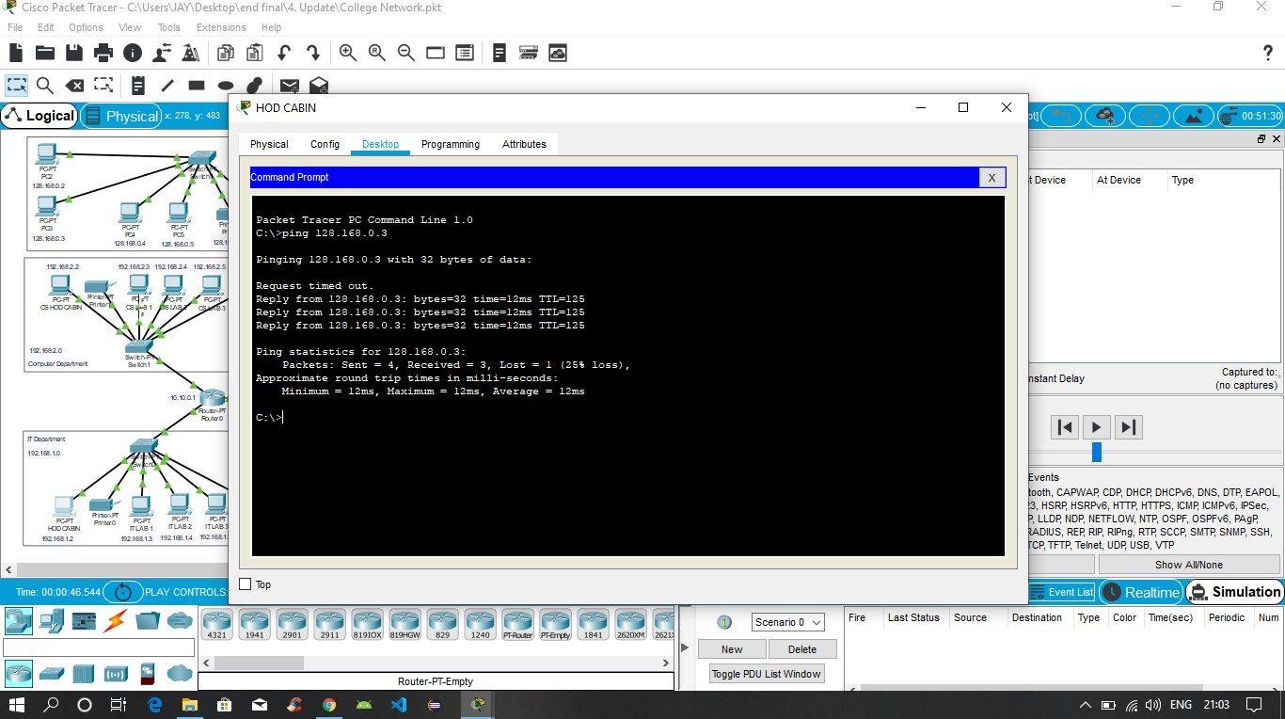

*Testing VLAN communications from HOD Cabin to Internet Lab*

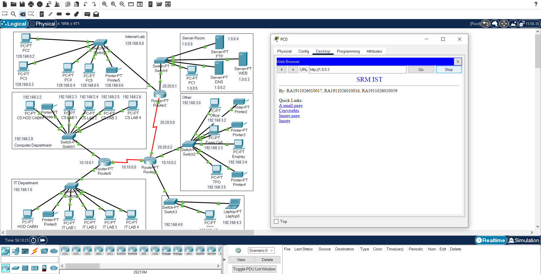

*Testing Web Hosting*

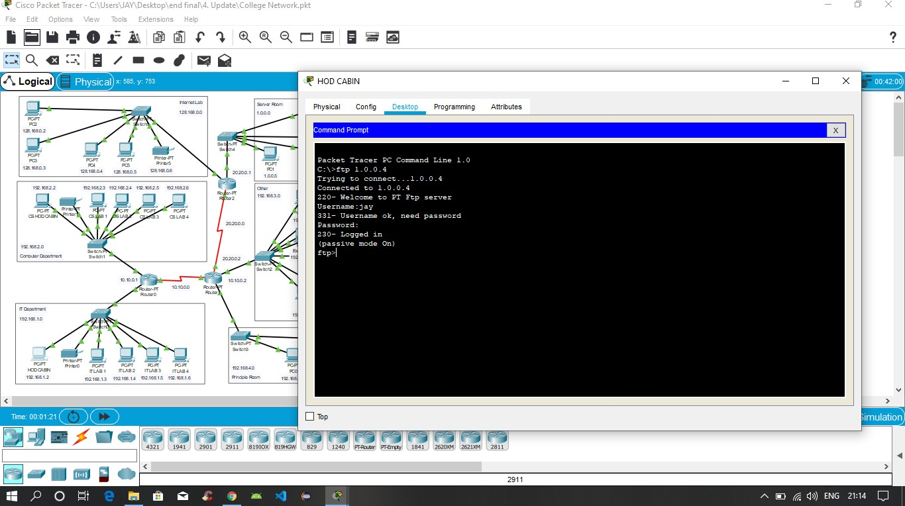

*Testing FTP Server*

**Conclusion**

A topology of a network that is a LAN (Local Area Network) for a College has been created in which various computers of different departments are set up so that they can interact and communicate with each other by interchanging data. CNS is used to design a systematic and well-planned topology, satisfying all the necessities of the college (i.e. client).

# References

1. Sun, L., Wu, J., Zhang, Y., & Yin, H. (2013, April). “Comparison between physical devices and simulator software for Cisco network technology teaching”. In Computer Science &Education (ICCSE), 2013 8th International Conference on (pp. 1357-1360). IEEE
2. Roberto Minerva AbiyBiru, "Towards a Definition of the Internet of Things” IEEE IOT Initiative white paper.
3. “Design and Simulation of Local Area Network Using Cisco Packet Tracer”. The International Journal of Engineering and Science (IJES) || Volume || 6 || Issue || 10 || Pages || PP 63- 77 || 2017 || ISSN (e): 2319 – 1813 ISSN (p): 2319 – 1805.
4. Qin, X. U. E. "Simulation Experimental Teaching of Computer Network Based on Packet Tracer [J]." Research and Exploration in Laboratory 2 (2010): 57-59.
5. Current, John R., Charles S. ReVelle, and Jared L. Cohon. "The hierarchical network design problem." European Journal of Operational Research 27.1 (1986): 57-66.